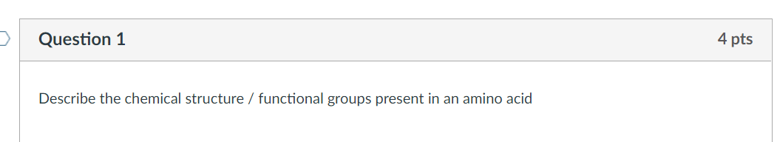

For this question number 2, my name is Jose
